The estimated time for each part is indicated by E.T.

# MCQ Write the letter of the most correct answer [E.T. =30][30 marks]

Part A: Lec1&2 Product Quality & Measuring system complexity:

1. Difference between verification and validation …..:

|  |  |
| --- | --- |
| 1. Verification is process of checking that developer built right product while validation is process of ensuring that the product is being built right | 1. Validation is process of checking that developer built right product while Verification is process of ensuring that the product is being built right |
| 1. Validation make sure that the system description consistent with customer requirements while verification make sure that system descriptions are self-consistent | 1. Both B and C |

1. Main problems of integration Testing

|  |  |
| --- | --- |
| 1. Time and Resource Constraints | 1. Polymorphism and inheritance |
| 1. Lack of isolation | 1. Cloud and virtualization |

1. Which of the following is software quality factors that are affected by product transition requirements ? ….. :

|  |  |
| --- | --- |
| 1. Usability | B) availability |
| 1. Interoperability | 1. Maintainability |

1. Which metric is used to measure the level of coupling between objects?

|  |  |
| --- | --- |
| 1. NOC metric | 1. ) DIT metric |
| 1. CBO metric | 1. None of the above |

1. What is the primary purpose of regression testing in software development? …..:

|  |  |
| --- | --- |
| 1. To test new features added to the software | 1. To ensure that changes to the software have not introduced new defects |
| 1. To verify that the software meets the customer's requirements | 1. To detect defects in the system |

1. Which of the following is NOT a goal of acceptance testing? …..:

|  |  |
| --- | --- |
| 1. To ensure that the software meets the customer's requirements | 1. To ensure that the software is ready for delivery to the customer |
| 1. To ensure that the software is user-friendly and easy to use | 1. To validate that the software works correctly in the production environment |

1. The Number-of-children (NOC) metric is used to measure:

|  |  |
| --- | --- |
| 1. The complexity of individual objects in a system | 1. The degree of interdependence between objects in a system |
| 1. The number of child classes derived from a parent class in a system | 1. The depth of the inheritance tree for a class in a system |

1. the best description for how the LOC metrics work is …..:

|  |  |
| --- | --- |
| 1. LOC measures the amount of time it takes to write code | 1. LOC measures the complexity of code based on the number of lines and as the lines increase implies more errors |
| 1. LOC measures the number of functions or methods in a codebase | 1. LOC measures the number of bugs or errors in a codebase |

1. Which of the following is true about the Depth-of-inheritance-tree (DIT) metric?

|  |  |
| --- | --- |
| 1. It is a measure of the number of direct sub-classes of a class | 1. It is a measure of the number of direct super-classes of a class |
| 1. It is a measure of the number of ancestors of a class | 1. It is a measure of the number of descendants of a class |

1. In the following code :

The McCabe's cyclomatic-complexity metric for this code …..:

|  |  |
| --- | --- |
| 1. 2 | 1. 3 |
| 1. 4 | 1. 5 |

1. the metric that measures the amount of interaction between classes in a system is

|  |  |
| --- | --- |
| 1. Depth-of-inheritance-tree metric | 1. Coupling-between-objects metric |
| 1. Number-of-children metric | 1. none of the following |

1. White box testing is a software testing method that focuses on:

|  |  |
| --- | --- |
| 1. Testing the user interface and functionality | 1. Testing the performance of the code |
| 1. Testing the internal logic of the code | 1. None of the above |

1. The basis-path testing technique is a:

|  |  |
| --- | --- |
| 1. Black box testing technique | 1. White box testing technique |
| 1. Both A and B | 1. None of the above |

1. the techniques of white box testing is …..:

|  |  |
| --- | --- |
| A) Error guessing technique and state transition technique | B) Basic path technique and loop technique |
| C) Boundary value technique and cause effect technique | D) Equivalence partitioning technique and use case technique |

1. the problems with black box testing is …..:

|  |  |
| --- | --- |
| 1. Results indicate poor coverage levels when testing strategy alone is pursued | 1. Concentrating on code of implementation and may not reveal the customer requirements as it is omitted from implementation |
| 1. It is time-consuming | 1. None of the following |

Part B: Lec3&4 Securing architecture:

16) Which view of software architecture describes the components, their relationships, and their interfaces?

|  |  |
| --- | --- |
| 1. The operational view | 1. The development view |
| 1. The functional view | 1. The deployment view |

1. the three principal layers of layers pattern is ….:

|  |  |
| --- | --- |
| 1. Presentation layer , physical layer and data source layer | 1. Presentation layer , domain layer and data source layer |
| 1. Presentation layer , domain layer and data link layer | 1. Presentation layer , network layer and data source layer |

17) Which layer is missing in the Three-layer pattern compared to the basic Layers pattern?

|  |  |
| --- | --- |
| 1. The third principal layer | 1. The first principal layer |
| 1. The second principal layer | 1. One of the mediating layers |

18) What is the primary function of the third principal layer in the Layers pattern?

|  |  |
| --- | --- |
| 1. To provide structural support | 1. To regulate the flow of information |
| 1. TO handle the storage of persistent data, and networking with other systems | 1. To send information to other regions of the brain |

1. The best situation to use mvc pattern is …. and the …. Component and …. component are both dependent on …. component in mvc pattern:

|  |  |
| --- | --- |
| 1. The model contains the data and business logic, while the view represents the user interface, and the controller handles user input and updates the model and view | 1. The model handles user input and output, while the view contains the data and business logic, and the controller presents the data to the user |
| 1. The model represents the user interface, while the view contains the data and business logic, and the controller handles user input | 1. The model and view are the same component in the MVC pattern, and the controller is responsible for managing data and business logic |

20) What is the main objective of the deployment view in software architecture?

|  |  |
| --- | --- |
| 1. To identify the logical structure of the software system | 1. To describe the interactions between the software components |
| 1. To specify the hardware and software infrastructure needed to run the system | 1. To describe the processes involved in software development |

21) The following statement is true about web service ….:

|  |  |
| --- | --- |
| 1. Web services allow two different applications to communicate with each other over a network, using standard protocols like HTTP and XML | B) Web services are not compatible with modern programming languages like Python and Ruby |
| C)Web services are a type of programming language used to create dynamic websites | D)Web services are primarily used for data storage and retrieval. |

1. The SOA infrastructure is composed of ……….:

|  |  |
| --- | --- |
| 1. Service | 1. Consumer |
| 1. Provider | 1. All of above |

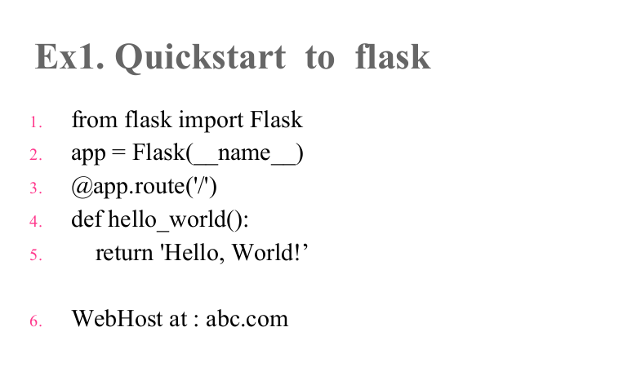23) According to this code : the action of (/) Endpoint is -------------

|  |  |
| --- | --- |
| 1. Forwards to your target URL | 1. Shows the created url_key with additional info, including a secret_key |
| 1. Shows administrative info about your shortened URL | 1. Returns a Hello, World! string |

@app.post("/url", response_model=schemas.URLInfo)

25def create_url(url: schemas.URLBase, db: Session = Depends(get_db)):

26 if not validators.url(url.target_url):

27 raise_bad_request(message="Your provided URL is not valid")

28

29 chars = "ABCDEFGHIJKLMNOPQRSTUVWXYZ"

30 key = "".join(secrets.choice(chars) for _ in range(5))

31 secret_key = "".join(secrets.choice(chars) for _ in range(8))

32 db_url = models.URL(

33 target_url=url.target_url, key=key, secret_key=secret_key

34 )

35 db.add(db_url)

36 db.commit()

37 db.refresh(db_url)

38 db_url.url = key

1. db_url.admin_url = secret_key

24)What is the purpose of line 26 and 27 ?

|  |  |
| --- | --- |
| 1. make sure that the provided target_url data is a valid URL | 1. provide random strings for key and secret_key. |
| 1. create a database entry for your target_url. | 1. match the required URLInfo schema that you need to return at the end of the function. |

1. What is the purpose of line 32 to 37 ?

|  |  |
| --- | --- |
| 1. make sure that the provided target_url data is a valid URL | 1. provide random strings for key and secret_key. |
| 1. create a database entry for your target_url. | 1. match the required URLInfo schema that you need to return at the end of the function. |

1. What is the purpose of line 38 and 39?

|  |  |
| --- | --- |
| 1. make sure that the provided target_url data is a valid URL | 1. provide random strings for key and secret_key. |
| 1. create a database entry for your target_url. | 1. match the required URLInfo schema that you need to return at the end of the function. |

1. A function decorator that tell Flask what URL should trigger our function is -----------

|  |  |
| --- | --- |
| 1. Route() | 1. Run() |
| 1. Api() | 1. Start() |

# Essay questions [E.T. =30] [30marks]

# Part A: Lec1

1. Fill the following table to show relations between 3 pairs of SQFs and their dependency:

|  |  |  |
| --- | --- | --- |
| SQF Name | SQF Name | Dependency |
|  |  |  |
|  |  |  |
|  |  |  |

Answer

|  |  |  |
| --- | --- | --- |
| **SQF Name** | **SQF Name** | **Dependency** |
| Integrity | Efficiency | dependent |
| Usability | Portability | conflicting |
| Portability | Maintainability | conflicting |
| Correctness | Reusability | Conflicting OR Independent  Justification is required |

1. ..

Answer: